**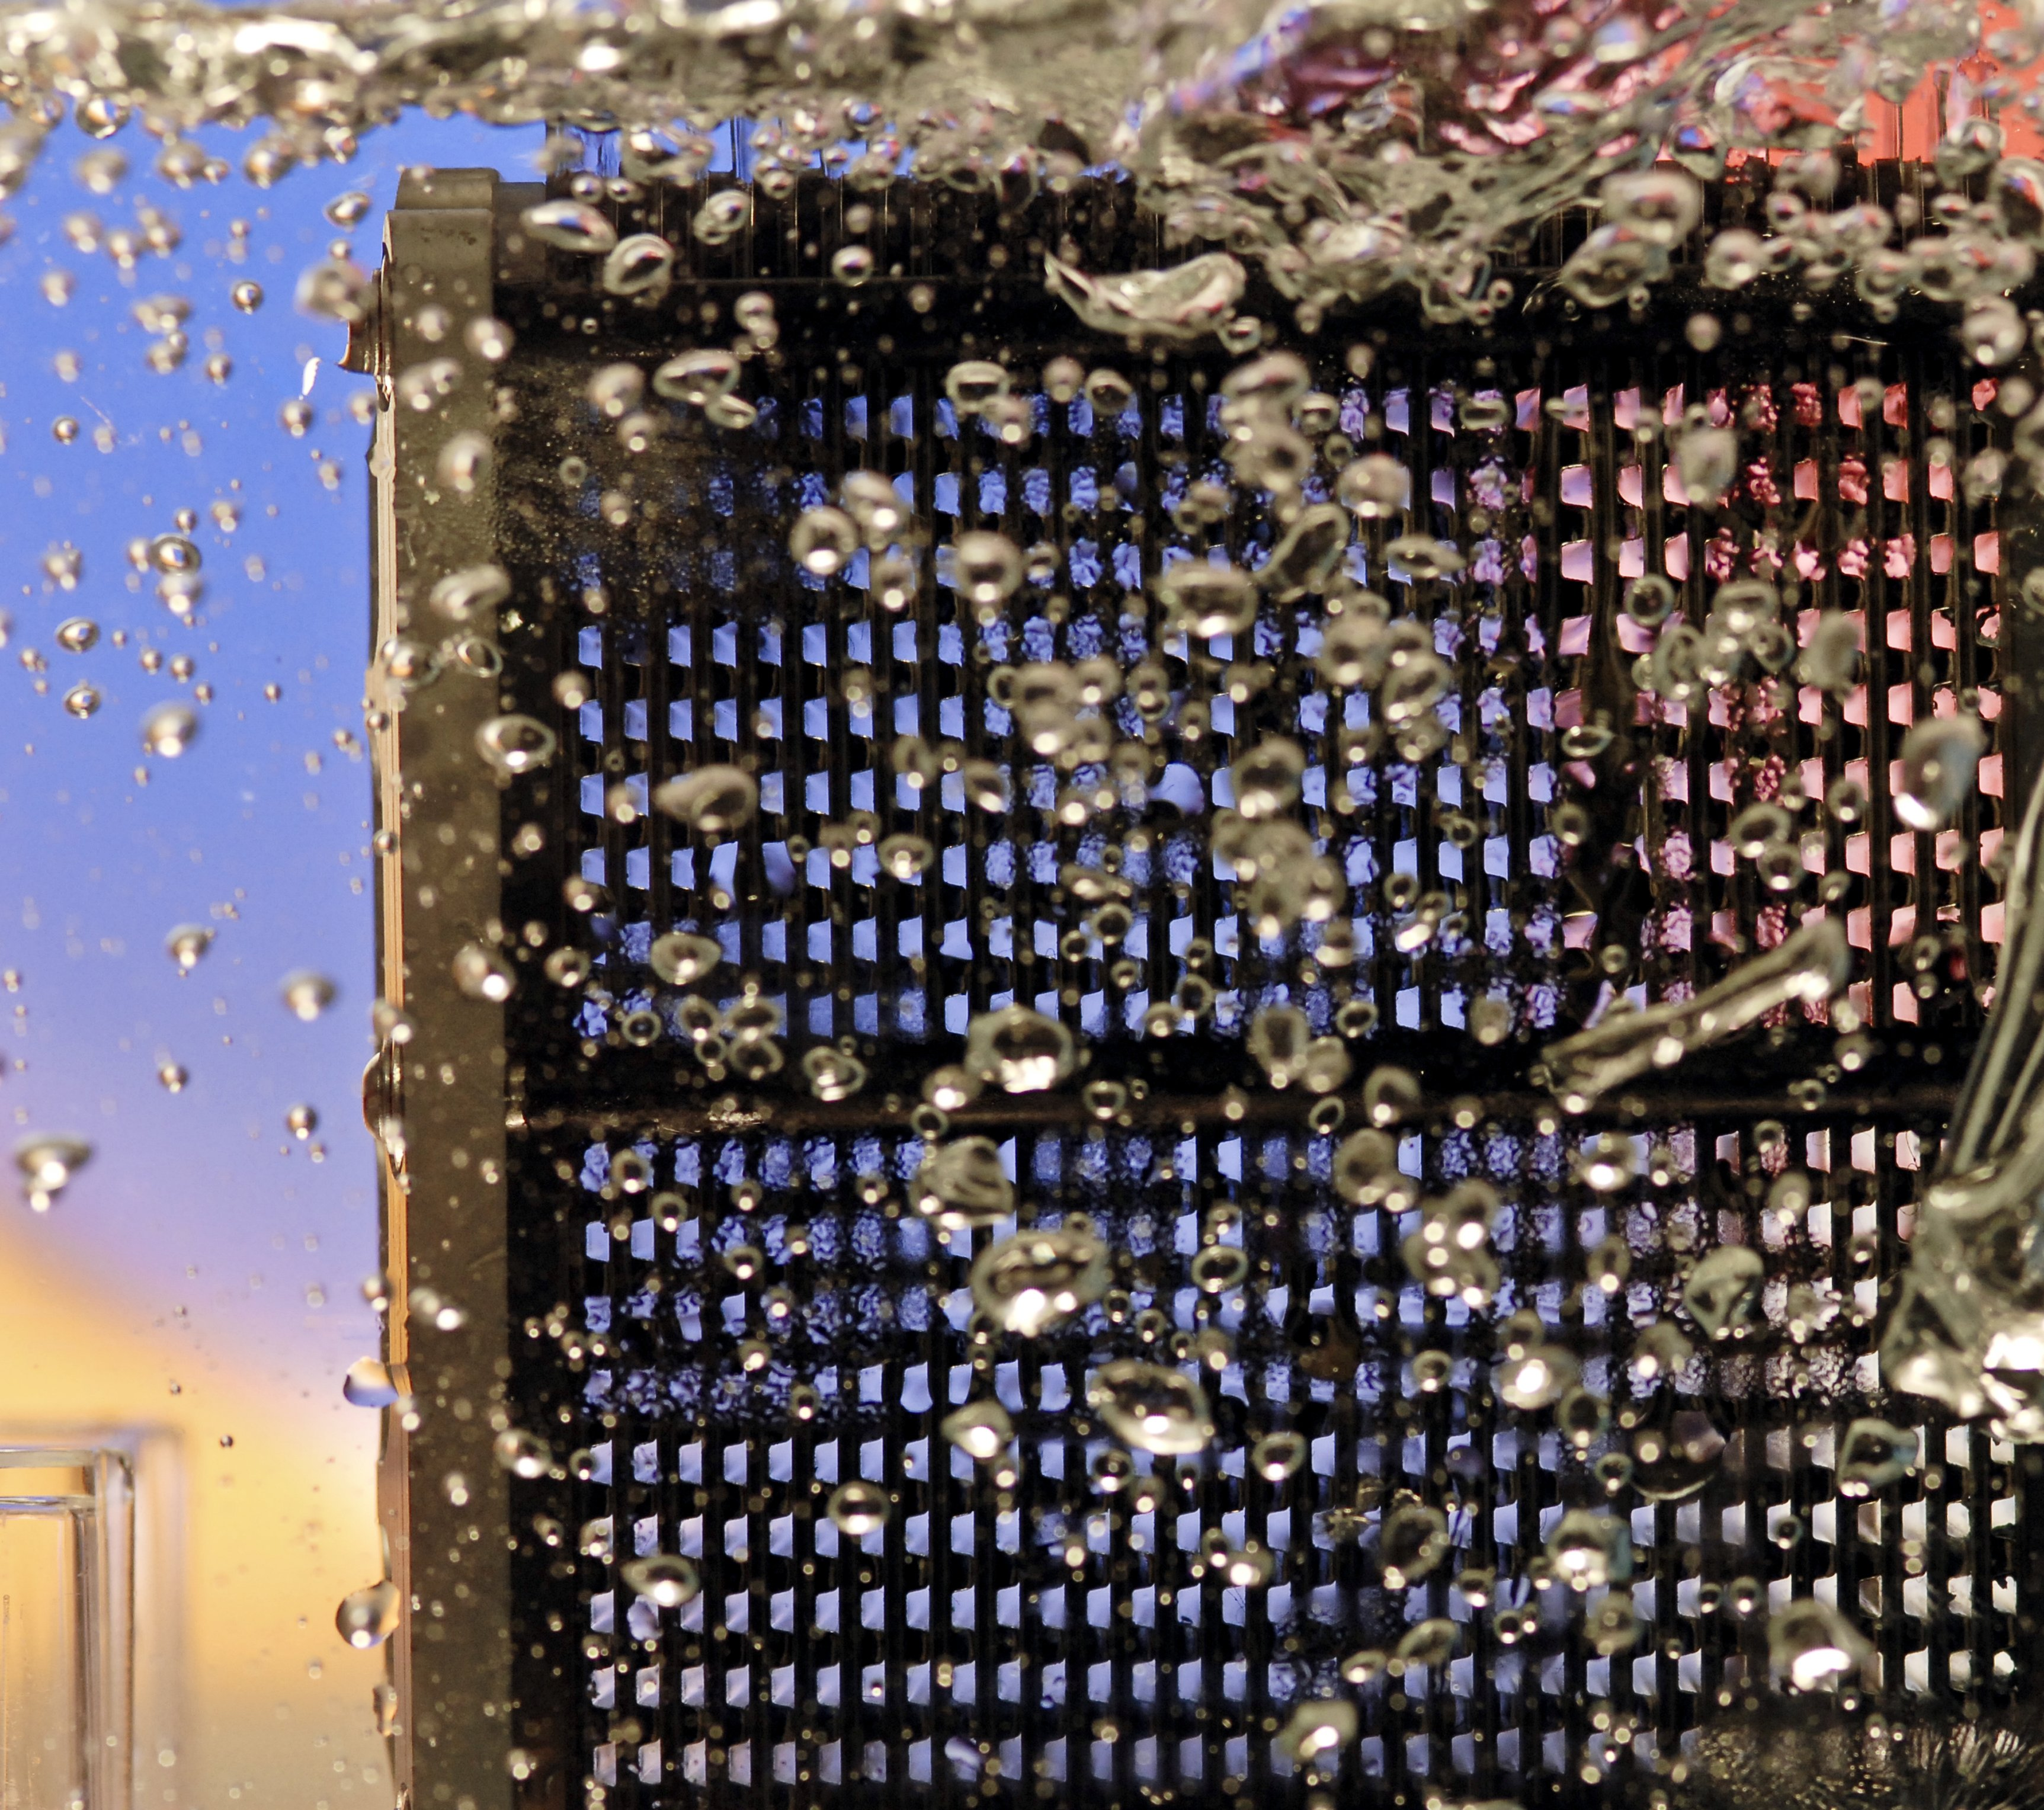**

|  |
| --- |
| FUEL CELL INDUSTRY ANALYSIS REPORT |
| 01/01/2015 |

Bambu, the team

|  |  |
| --- | --- |
| C:\Users\Konstantin Neumann\Documents\01_Dokumente & Daten 2015\CV\pictures\picture.jpg | ****Benoit Serot****  Lorem ipsum dolor sit amet, consectetuer adipiscing elit. Nam nibh. Nunc varius facilisis eros. Sed erat. In in velit quis arcu ornare laoreet. Curabitur adipiscing luctus massa. Integer ut purus ac augue commodo commodo. Nunc nec mi eu justo tempor consectetuer |
|  |  |
| C:\Users\Konstantin Neumann\Documents\01_Dokumente & Daten 2015\CV\pictures\picture.jpg | **Pongsathorn Tiranun**  Lorem ipsum dolor sit amet, consectetuer adipiscing elit. Nam nibh. Nunc varius facilisis eros. Sed erat. In in velit quis arcu ornare laoreet. Curabitur adipiscing luctus massa. Integer ut purus ac augue commodo commodo. Nunc nec mi eu justo tempor consectetuer |
|  |  |
| C:\Users\Konstantin Neumann\Documents\01_Dokumente & Daten 2015\CV\pictures\picture.jpg | **Konstantin Neumann**  Lorem ipsum dolor sit amet, consectetuer adipiscing elit. Nam nibh. Nunc varius facilisis eros. Sed erat. In in velit quis arcu ornare laoreet. Curabitur adipiscing luctus massa. Integer ut purus ac augue commodo commodo. Nunc nec mi eu justo tempor consectetuer |
|  |  |
| C:\Users\Konstantin Neumann\Documents\01_Dokumente & Daten 2015\CV\pictures\picture.jpg | **Shouka Arabi**  Lorem ipsum dolor sit amet, consectetuer adipiscing elit. Nam nibh. Nunc varius facilisis eros. Sed erat. In in velit quis arcu ornare laoreet. Curabitur adipiscing luctus massa. Integer ut purus ac augue commodo commodo. Nunc nec mi eu justo tempor consectetuer |

Table of contents

[Part 1: Introduction 3](#_Toc417860537)

[1.1 Intentions 3](#_Toc417860538)

[1.2 History of fuel cells 4](#_Toc417860539)

[1.3 Fuel cell as an alternative 4](#_Toc417860540)

[1.4 Short industry overview 4](#_Toc417860541)

[Part 2: Product description Error! Bookmark not defined.](#_Toc417860542)

[2.1 Introduction 5](#_Toc417860543)

[2.2 Technologies 6](#_Toc417860544)

[2.3 Applications 6](#_Toc417860545)

[2.4 Infrastructure 7](#_Toc417860546)

[Part 3: Future perspectives 9](#_Toc417860547)

[3.1 Opportunities 17](#_Toc417860548)

[3.2 Limitations and risks 18](#_Toc417860549)

[3.3 Forecast 18](#_Toc417860550)

[Part 4: Conclusion 20](#_Toc417860551)

[Part 5: Appendix 22](#_Toc417860552)

[5.1 Detailed table of contents 22](#_Toc417860553)

[5.2 Table of figures 23](#_Toc417860554)

[5.3 References 23](#_Toc417860555)

# Introduction

## Intentions

Lorem ipsum dolor sit amet, consectetuer adipiscing elit. Nam nibh. Nunc varius facilisis eros. Sed erat. In in velit quis arcu ornare laoreet. Curabitur adipiscing luctus massa. Integer ut purus ac augue commodo commodo. Nunc nec mi eu justo tempor consectetuer. Etiam vitae nisl. In dignissim lacus ut ante. Cras elit lectus, bibendum a, adipiscing vitae, commodo et, dui. Ut tincidunt tortor. Donec nonummy, enim in lacinia pulvinar, velit tellus scelerisque augue, ac posuere libero urna eget neque. Cras ipsum. Vestibulum pretium, lectus nec venenatis volutpat, purus lectus ultrices risus, a condimentum risus mi et quam. Pellentesque auctor fringilla neque. Duis eu massa ut lorem iaculis vestibulum. Maecenas facilisis elit sed justo. Quisque volutpat malesuada velit.   
  
Nunc at velit quis lectus nonummy eleifend. Curabitur eros. Aenean ligula dolor, gravida auctor, auctor et, suscipit in, erat. Sed malesuada, enim ut congue pharetra, massa elit convallis pede, ornare scelerisque libero neque ut neque. In at libero. Curabitur molestie. Sed vel neque. Proin et dolor ac ipsum elementum malesuada. Praesent id orci. Donec hendrerit. In hac habitasse platea dictumst. Aenean sit amet arcu a turpis posuere pretium.   
  
Nulla mauris odio, vehicula in, condimentum sit amet, tempus id, metus. Donec at nisi sit amet felis blandit posuere. Aliquam erat volutpat. Cras lobortis orci in quam porttitor cursus. Aenean dignissim. Curabitur facilisis sem at nisi laoreet placerat. Duis sed ipsum ac nibh mattis feugiat. Proin sed purus. Vivamus lectus ipsum, rhoncus sed, scelerisque sit amet, ultrices in, dolor. Aliquam vel magna non nunc ornare bibendum. Sed libero. Maecenas at est. Vivamus ornare, felis et luctus dapibus, lacus leo convallis diam, eget dapibus augue arcu eget arcu.   
  
Fusce auctor, metus eu ultricies vulputate, sapien nibh faucibus ligula, eget sollicitudin augue risus et dolor. Aenean pellentesque, tortor in cursus mattis, ante diam malesuada ligula, ac vestibulum neque turpis ut enim. Cras ornare. Proin ac nisi. Praesent laoreet ante tempor urna. In imperdiet. Nam ut metus et orci fermentum nonummy. Cras vel nunc. Donec feugiat neque eget purus. Quisque rhoncus. Phasellus tempus massa aliquet urna. Integer fringilla quam eget dolor. Curabitur mattis. Aliquam ac lacus. In congue, odio ut tristique adipiscing, diam leo fermentum ipsum, nec sollicitudin dui quam et tortor. Proin id neque ac pede egestas lacinia. Curabitur non odio.   
  
Nullam porta urna quis mauris. Aliquam erat volutpat. Donec scelerisque quam vitae est. Aenean vitae diam at erat pellentesque condimentum. Duis pulvinar nisl sed orci. Vivamus turpis nisi, volutpat in, placerat et, pharetra nec, eros. Suspendisse tellus metus, sodales non, venenatis a, ultrices auctor, erat. In ut leo nec elit mattis pellentesque. Sed eros elit, cursus accumsan, sollicitudin a, iaculis quis, diam. Pellentesque fermentum, pede a nonummy varius, ligula velit laoreet erat, et lacinia nibh nulla sit amet nunc. Suspendisse at turpis quis augue pellentesque pretium. Nunc condimentum elit semper felis.

## History of fuel cells

## Fuel cell as an alternative

## Short industry overview

# Product description

## Introduction

Lorem ipsum dolor sit amet, consectetuer adipiscing elit. Nam nibh. Nunc varius facilisis eros. Sed erat. In in velit quis arcu ornare laoreet. Curabitur adipiscing luctus massa. Integer ut purus ac augue commodo commodo. Nunc nec mi eu justo tempor consectetuer. Etiam vitae nisl. In dignissim lacus ut ante. Cras elit lectus, bibendum a, adipiscing vitae, commodo et, dui. Ut tincidunt tortor. Donec nonummy, enim in lacinia pulvinar, velit tellus scelerisque augue, ac posuere libero urna eget neque. Cras ipsum. Vestibulum pretium, lectus nec venenatis volutpat, purus lectus ultrices risus, a condimentum risus mi et quam. Pellentesque auctor fringilla neque. Duis eu massa ut lorem iaculis vestibulum. Maecenas facilisis elit sed justo. Quisque volutpat malesuada velit.   
  
Nunc at velit quis lectus nonummy eleifend. Curabitur eros. Aenean ligula dolor, gravida auctor, auctor et, suscipit in, erat. Sed malesuada, enim ut congue pharetra, massa elit convallis pede, ornare scelerisque libero neque ut neque. In at libero. Curabitur molestie. Sed vel neque. Proin et dolor ac ipsum elementum malesuada. Praesent id orci. Donec hendrerit. In hac habitasse platea dictumst. Aenean sit amet arcu a turpis posuere pretium.   
  
Nulla mauris odio, vehicula in, condimentum sit amet, tempus id, metus. Donec at nisi sit amet felis blandit posuere. Aliquam erat volutpat. Cras lobortis orci in quam porttitor cursus. Aenean dignissim. Curabitur facilisis sem at nisi laoreet placerat. Duis sed ipsum ac nibh mattis feugiat. Proin sed purus. Vivamus lectus ipsum, rhoncus sed, scelerisque sit amet, ultrices in, dolor. Aliquam vel magna non nunc ornare bibendum. Sed libero. Maecenas at est. Vivamus ornare, felis et luctus dapibus, lacus leo convallis diam, eget dapibus augue arcu eget arcu.

## Technologies

Lorem ipsum dolor sit amet, consectetuer adipiscing elit. Nam nibh. Nunc varius facilisis eros. Sed erat. In in velit quis arcu ornare laoreet. Curabitur adipiscing luctus massa. Integer ut purus ac augue commodo commodo. Nunc nec mi eu justo tempor consectetuer. Etiam vitae nisl. In dignissim lacus ut ante. Cras elit lectus, bibendum a, adipiscing vitae, commodo et, dui. Ut tincidunt tortor. Donec nonummy, enim in lacinia pulvinar, velit tellus scelerisque augue, ac posuere libero urna eget neque. Cras ipsum. Vestibulum pretium, lectus nec venenatis volutpat, purus lectus ultrices risus, a condimentum risus mi et quam. Pellentesque auctor fringilla neque. Duis eu massa ut lorem iaculis vestibulum. Maecenas facilisis elit sed justo. Quisque volutpat malesuada velit.   
  
Nunc at velit quis lectus nonummy eleifend. Curabitur eros. Aenean ligula dolor, gravida auctor, auctor et, suscipit in, erat. Sed malesuada, enim ut congue pharetra, massa elit convallis pede, ornare scelerisque libero neque ut neque. In at libero. Curabitur molestie. Sed vel neque. Proin et dolor ac ipsum elementum malesuada. Praesent id orci. Donec hendrerit. In hac habitasse platea dictumst. Aenean sit amet arcu a turpis posuere pretium.   
  
Nulla mauris odio, vehicula in, condimentum sit amet, tempus id, metus. Donec at nisi sit amet felis blandit posuere. Aliquam erat volutpat. Cras lobortis orci in quam porttitor cursus. Aenean dignissim. Curabitur facilisis sem at nisi laoreet placerat. Duis sed ipsum ac nibh mattis feugiat. Proin sed purus. Vivamus lectus ipsum, rhoncus sed, scelerisque sit amet, ultrices in, dolor. Aliquam vel magna non nunc ornare bibendum. Sed libero. Maecenas at est. Vivamus ornare, felis et luctus dapibus, lacus leo convallis diam, eget dapibus augue arcu eget arcu.

### PEMFC

### AFC

### PAFC

### SOFC

### MCFC

### DMFC

### Summary

## Applications

Lorem ipsum dolor sit amet, consectetuer adipiscing elit. Nam nibh. Nunc varius facilisis eros. Sed erat. In in velit quis arcu ornare laoreet. Curabitur adipiscing luctus massa. Integer ut purus ac augue commodo commodo. Nunc nec mi eu justo tempor consectetuer. Etiam vitae nisl. In dignissim lacus ut ante. Cras elit lectus, bibendum a, adipiscing vitae, commodo et, dui. Ut tincidunt tortor. Donec nonummy, enim in lacinia pulvinar, velit tellus scelerisque augue, ac posuere libero urna eget neque. Cras ipsum. Vestibulum pretium, lectus nec venenatis volutpat, purus lectus ultrices risus, a condimentum risus mi et quam. Pellentesque auctor fringilla neque. Duis eu massa ut lorem iaculis vestibulum. Maecenas facilisis elit sed justo. Quisque volutpat malesuada velit.   
  
Nunc at velit quis lectus nonummy eleifend. Curabitur eros. Aenean ligula dolor, gravida auctor, auctor et, suscipit in, erat. Sed malesuada, enim ut congue pharetra, massa elit convallis pede, ornare scelerisque libero neque ut neque. In at libero. Curabitur molestie. Sed vel neque. Proin et dolor ac ipsum elementum malesuada. Praesent id orci. Donec hendrerit. In hac habitasse platea dictumst. Aenean sit amet arcu a turpis posuere pretium.   
  
Nulla mauris odio, vehicula in, condimentum sit amet, tempus id, metus. Donec at nisi sit amet felis blandit posuere. Aliquam erat volutpat. Cras lobortis orci in quam porttitor cursus. Aenean dignissim. Curabitur facilisis sem at nisi laoreet placerat. Duis sed ipsum ac nibh mattis feugiat. Proin sed purus. Vivamus lectus ipsum, rhoncus sed, scelerisque sit amet, ultrices in, dolor. Aliquam vel magna non nunc ornare bibendum. Sed libero. Maecenas at est. Vivamus ornare, felis et luctus dapibus, lacus leo convallis diam, eget dapibus augue arcu eget arcu.

### Categorisation choices

### Transport

### Portable

### Stationary

## Infrastructure

Lorem ipsum dolor sit amet, consectetuer adipiscing elit. Nam nibh. Nunc varius facilisis eros. Sed erat. In in velit quis arcu ornare laoreet. Curabitur adipiscing luctus massa. Integer ut purus ac augue commodo commodo. Nunc nec mi eu justo tempor consectetuer. Etiam vitae nisl. In dignissim lacus ut ante. Cras elit lectus, bibendum a, adipiscing vitae, commodo et, dui. Ut tincidunt tortor. Donec nonummy, enim in lacinia pulvinar, velit tellus scelerisque augue, ac posuere libero urna eget neque. Cras ipsum. Vestibulum pretium, lectus nec venenatis volutpat, purus lectus ultrices risus, a condimentum risus mi et quam. Pellentesque auctor fringilla neque. Duis eu massa ut lorem iaculis vestibulum. Maecenas facilisis elit sed justo. Quisque volutpat malesuada velit.   
  
Nunc at velit quis lectus nonummy eleifend. Curabitur eros. Aenean ligula dolor, gravida auctor, auctor et, suscipit in, erat. Sed malesuada, enim ut congue pharetra, massa elit convallis pede, ornare scelerisque libero neque ut neque. In at libero. Curabitur molestie. Sed vel neque. Proin et dolor ac ipsum elementum malesuada. Praesent id orci. Donec hendrerit. In hac habitasse platea dictumst. Aenean sit amet arcu a turpis posuere pretium.   
  
Nulla mauris odio, vehicula in, condimentum sit amet, tempus id, metus. Donec at nisi sit amet felis blandit posuere. Aliquam erat volutpat. Cras lobortis orci in quam porttitor cursus. Aenean dignissim. Curabitur facilisis sem at nisi laoreet placerat. Duis sed ipsum ac nibh mattis feugiat. Proin sed purus. Vivamus lectus ipsum, rhoncus sed, scelerisque sit amet, ultrices in, dolor. Aliquam vel magna non nunc ornare bibendum. Sed libero. Maecenas at est. Vivamus ornare, felis et luctus dapibus, lacus leo convallis diam, eget dapibus augue arcu eget arcu.

### Distribution facilities

#### Delivery

#### Hydrogen storage

### Hydrogen production

#### Introduction

#### Electrolysis

#### Steam reforming

#### Summary

**CHP:**

Combined Heat and Power

**FCEV:**

Fuel Cell Electric Vehicle

# Market Perspective

## Introduction

In general, fuel cells are devices capable of combining hydrogen and oxygen thus, obtaining electricity, water and heat in the process. And it differs from batteries because of the fact that it would continually produce electricity as long as hydrogen is being provided to the cells, it also differs from the conventional energy sources due to it does not burn fuel, thus it hold few advantages :

1. The generation process is quiet
2. The process is pollution-free
3. It’s two to three times more efficient than combustion[[1]](#footnote-1)

The markets for fuel cells can be classified into:

1. stationary power: applications where the fuel cells are working at a stationary or fixed location mostly for primary power, CHP or backup power sources;
2. transportation power: applications where fuel cells are used in transportation vehicles like passenger cars, buses and other FCEVs ;
3. and portable power: applications where fuel cells are in portable electronic devices like MP3 players, laptops, mobliephones.

## Investment Cost Reduction

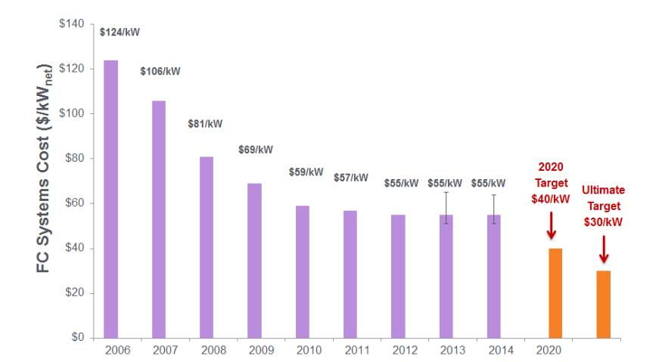[[2]](#footnote-2)

In the last decade, the cost of fuel cells continued to decline significantly in terms of the average capital needed in order to generate a unit kilowatt of energy using fuel cells, as its is pointed out in the figure above that the cost of fuel cells decreased by fifty percent in a period of five years mainly because R&D departments of many companies attempted and succeeded to some extents in making the fuel cell prices comparable with conventional energy sources. At the same time, it was discovered that durability of the cells has increased by two times in general.[[3]](#footnote-3) The fuel cells cost have then been quite stable for three yoears till now. However, experts projected that the investment cos t will again decrease furthur in the year 2020, due to fuel cells will be actively used in public transportation.[[4]](#footnote-4)

~~3.3 Research and Development Fundings~~

(Removed due to insufficient data online)

## Top Investors

Lorem ipsum dolor sit amet, consectetuer adipiscing elit. Nam nibh. Nunc varius facilisis eros. Sed erat. In in velit quis arcu ornare laoreet. Curabitur adipiscing luctus massa. Integer ut purus ac augue commodo commodo. Nunc nec mi eu justo tempor consectetuer. Etiam vitae nisl. In dignissim lacus ut ante. Cras elit lectus, bibendum a, adipiscing vitae, commodo et, dui. Ut tincidunt tortor. Donec nonummy, enim in lacinia pulvinar, velit tellus scelerisque augue, ac posuere libero urna eget neque. Cras ipsum.

## Quantity of Fuel Cells shipped

Lorem ipsum dolor sit amet, consectetuer adipiscing elit. Nam nibh. Nunc varius facilisis eros. Sed erat. In in velit quis arcu ornare laoreet. Curabitur adipiscing luctus massa. Integer ut purus ac augue commodo commodo. Nunc nec mi eu justo tempor consectetuer. Etiam vitae nisl. In dignissim lacus ut ante. Cras elit lectus, bibendum a, adipiscing vitae, commodo et, dui. Ut tincidunt tortor. Donec nonummy, enim in lacinia pulvinar, velit tellus scelerisque augue, ac posuere libero urna eget neque. Cras ipsum.

## Hydrogen Refuelling Stations

Lorem ipsum dolor sit amet, consectetuer adipiscing elit. Nam nibh. Nunc varius facilisis eros. Sed erat. In in velit quis arcu ornare laoreet. Curabitur adipiscing luctus massa. Integer ut purus ac augue commodo commodo. Nunc nec mi eu justo tempor consectetuer. Etiam vitae nisl. In dignissim lacus ut ante. Cras elit lectus, bibendum a, adipiscing vitae, commodo et, dui. Ut tincidunt tortor. Donec nonummy, enim in lacinia pulvinar, velit tellus scelerisque augue, ac posuere libero urna eget neque. Cras ipsum.

## 

## Company Profiles

Currently the fuel cell market is flourished with many companies developing a variety of different products ranging from small hand held fuel cell mp3 players to big substations used to power backup for vital communications. Our group decided to give introduction to all the aspects of fuel cells, therefore introduction to fuel cell companies from all corners of the world are covered in this chapter. Notice that this is not the complete list of all the manufacturers, since there are many public and private companies in existence but the profiles provided in this chapter should prove significant to give insight to the entire fuel cell industry.

Here is the list of companies included in this IAR in alphabetical order:

* Bloom Energy
* Horizon Fuel Cell Technologies
* Intelligent Energy
* Nedstack
* Panasonic
* Plug Power
* SFC Energy
* Toshiba

### Bloom Energy

**SOFC:**

Solid Oxide Fuel Cells

The company was founded in the year 2001 and is headquartered in Sunnyvale, California. Its first customer was the University of Tennessee, which ordered the company a SOFC product for educational purposes in 2006. Many other university across the United States similarly ordered the same product to conduct field trials. But it wasn’t until July of 2008 that the first commercial version of Bloom Energy’s products were shipped to Google. The company proved to be one of the highest ranked SOFC producers since then some notable customers of this firm includes Adobe, Bank of America, Coca-Cola, eBay, Google, Kaiser Permanente, and Walmart. The Company claimed that their products have already generated more than 100 million kilowatt-hours of clean energy for its customers.[[5]](#footnote-5)

|  |  |
| --- | --- |
| Headquarters | California, USA |
| Fuel Cell Type | SOFC |
| Market | Stationary (Large-Scale) |
| Application | Buildings(commercial, universities, arenas) data centers |

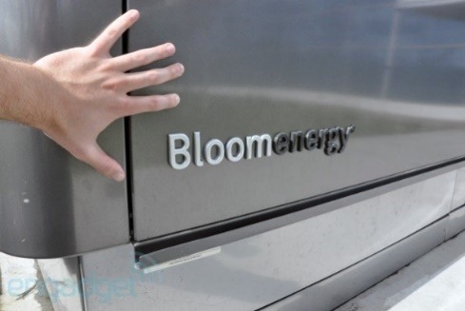[[6]](#footnote-6)

### Horizon Fuel Cell Technologies

**PEM:**

Proton Exchange Membrane

Horizon is currently the largest micro fuel cell producer and the largest producer of PEM fuel cell stacks below 1,000 W. Today, the firm produces compact, lightweight PEM fuel cells at various performance levels, and also delivers hydrogen storage and on-site hydrogen generation solutions for multiple applications. The company was founded in 2003 and it currently own five subsidiaries around the globe.[[7]](#footnote-7)

|  |  |
| --- | --- |
| Headquarters | Singapore |
| Fuel Cell Type | PEM |
| Market | Portable, Stationary(backup) |
| Application | Educational, consumer electronics, military, aerospace |

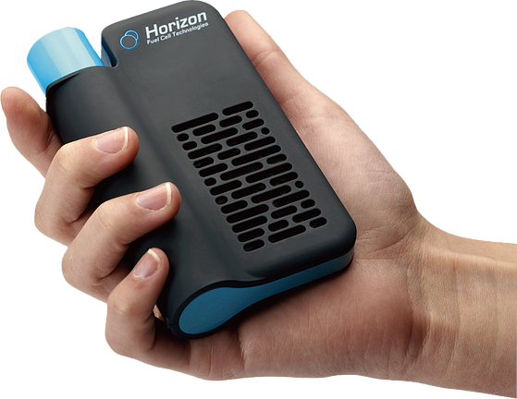

### Intelligent Energy

[[8]](#footnote-8)

Intelligent Energy was founded in Loughborough, United Kingdom 2001. Its main focuses are Proton Exchange Membrane type fuel cells. The firm partners with global companies that research on automotive, stationary power, and consumer electronics markets. Very notable accomplishments include collaborating with Suzuki Motor Corporation and built “Burgman” the first fuel cell scooter to achieve European Whole Vehicle Type Approval, and supplying fuel cells to Boeing who used it for the first fuel cell aircraft.[[9]](#footnote-9)

|  |  |
| --- | --- |
| Headquarters | Loughborough, United Kingdoms |
| Fuel Cell Type | PEM |
| Market | Portable, Stationary(backup) |
| Application | Aerospace, defense, generation portable power, automotive |



### Nedstack



Nedstack is a PEM fuel cell stack provider for system integrators who delivers energy systems to the telecom, rail, and utilities industries. The company was founded in 1998 when seven engineers took over AkzoNobel’s PEM activities. Right now, over 1,000 Nedstack fuel cells are in operation world-wide mostly as backup power sources.[[10]](#footnote-10)

|  |  |
| --- | --- |
| Headquarters | Amhem, The Netherlands |
| Fuel Cell Type | PEM |
| Market | Transportation, Stationary(backup) |
| Application | Stationary power, telecommunication backup, buses |

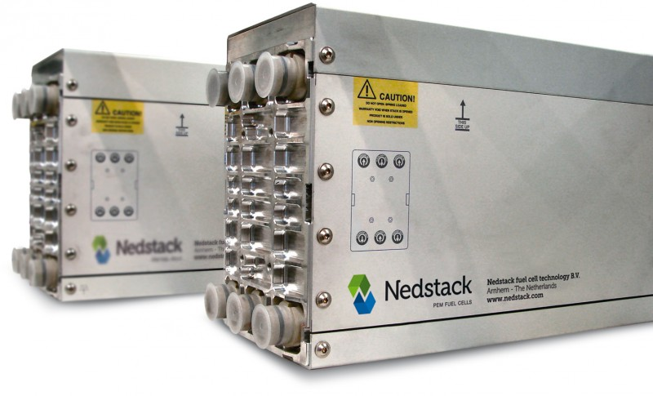[[11]](#footnote-11)

### Panasonic

**DMFC:**

Direct Methanol Fuel Cell



The firm was founded in the year 1918, at the moment it was known as Matsushita Electronics, the company now comprises of more than 500 sub companies. The company was the first to manufacture a DMFC laptop which was capable for operating continually on battery for 20 hours and displayed it publicly at the International Consumer Electronics Show, 2006 ’. The firm is also one of the largest global manufacturers for residential CHP, and in recent years, the company managed to miniature and simplify fuel cell’s structures.[[12]](#footnote-12)[[13]](#footnote-13)

|  |  |
| --- | --- |
| Headquarters | Osaka, Japan |
| Fuel Cell Type | DMFC,PEM |
| Market | Stationary, Portable |
| Application | CHP units, Consumer Electronics,DMFC |

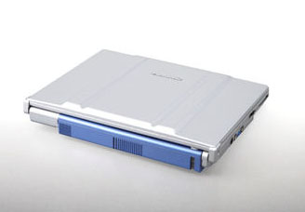[[14]](#footnote-14)

### Plug Power



Plug Power is a major player in the PEM fuel cell material handling equipment market. The company was incorporated the year 1997 as a joint venture between Edison Development Corporation and Mechanical Technology Inc. Right now, the company mainly focuses on GenDrive®, a PEMFC designed for industrial vehicles especially material handling equipment and distribution facilities. The company has deployed over 3,000 GenDrive® units with run times exceeding 8.5 million hours.[[15]](#footnote-15)

|  |  |
| --- | --- |
| Headquarters | Latham, New York |
| Fuel Cell Type | PEM |
| Market | Stationary, Transportation |
| Application | Material Handling Equipment |

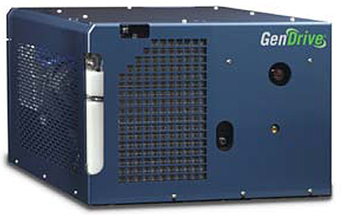[[16]](#footnote-16)

### SFC Energy



The firm produces power generator for mobile homes, yachts and vacation cabins. SFC Energy ally itself with other big companies in different industries and had already shipped more than 30,000 commercial products. The company’s facilities are located mainly in the Netherlands and Romania, its fuel cartridges are manufactured in Germany near Munich where its R&D department is located. SFC Energy also manufactures DMFC for mobile and off-grid power serving leisure, industrial and defense market.[[17]](#footnote-17)

|  |  |
| --- | --- |
| Headquarters | Brunnthal, Germany |
| Fuel Cell Type | DMFC |
| Market | Stationary |
| Application | Leisure, industrial and defense |

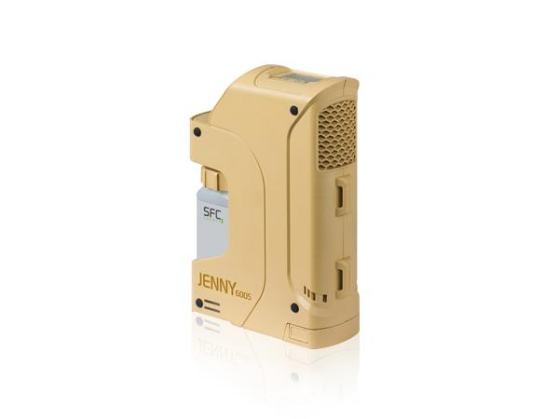[[18]](#footnote-18)

### Toshiba



**CEATEC:**

Combined Exhibition of Advanced Technologies, an annual tradeshow in Japan.

In the year 1984, Toshiba operated an experimental 50 kW fuel cell power plant, the first power plant in Japan. The company actively research on DMFC and PEM technologies for the Japanese market. Among the main products are residential PEM fuel cells and PAFC developed since 1990s. The company also demonstrates its DMFC- powered cell phones and MP3 players at the CEATEC conference which can operate for 320 hours using fuel cell and methanol fuel.[[19]](#footnote-19)

|  |  |
| --- | --- |
| Headquarters | Tokyo, Japan |
| Fuel Cell Type | DMFC, PEM |
| Market | Stationary, Portable |
| Application | Consumer Electronics, Residential |

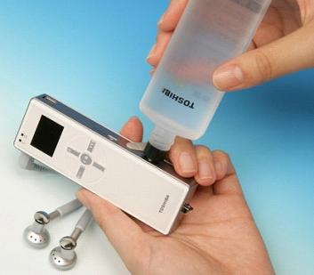[[20]](#footnote-20)

# Law and governmental regulations

## Forms of influence

Lorem ipsum dolor sit amet, consectetuer adipiscing elit. Nam nibh. Nunc varius facilisis eros. Sed erat. In in velit quis arcu ornare laoreet. Curabitur adipiscing luctus massa. Integer ut purus ac augue commodo commodo. Nunc nec mi eu justo tempor consectetuer. Etiam vitae nisl. In dignissim lacus ut ante. Cras elit lectus, bibendum a, adipiscing vitae, commodo et, dui. Ut tincidunt tortor. Donec nonummy, enim in lacinia pulvinar, velit tellus scelerisque augue, ac posuere libero urna eget neque. Cras ipsum. Vestibulum pretium, lectus nec venenatis volutpat, purus lectus ultrices risus, a condimentum risus mi et quam. Pellentesque auctor fringilla neque. Duis eu massa ut lorem iaculis vestibulum. Maecenas facilisis elit sed justo. Quisque volutpat malesuada velit.   
  
Nunc at velit quis lectus nonummy eleifend. Curabitur eros. Aenean ligula dolor, gravida auctor, auctor et, suscipit in, erat. Sed malesuada, enim ut congue pharetra, massa elit convallis pede, ornare scelerisque libero neque ut neque. In at libero. Curabitur molestie. Sed vel neque. Proin et dolor ac ipsum elementum malesuada. Praesent id orci. Donec hendrerit. In hac habitasse platea dictumst. Aenean sit amet arcu a turpis posuere pretium.   
  
Nulla mauris odio, vehicula in, condimentum sit amet, tempus id, metus. Donec at nisi sit amet felis blandit posuere. Aliquam erat volutpat. Cras lobortis orci in quam porttitor cursus. Aenean dignissim. Curabitur facilisis sem at nisi laoreet placerat. Duis sed ipsum ac nibh mattis feugiat. Proin sed purus. Vivamus lectus ipsum, rhoncus sed, scelerisque sit amet, ultrices in, dolor. Aliquam vel magna non nunc ornare bibendum. Sed libero. Maecenas at est. Vivamus ornare, felis et luctus dapibus, lacus leo convallis diam, eget dapibus augue arcu eget arcu.

## Situation in Japan

Lorem ipsum dolor sit amet, consectetuer adipiscing elit. Nam nibh. Nunc varius facilisis eros. Sed erat. In in velit quis arcu ornare laoreet. Curabitur adipiscing luctus massa. Integer ut purus ac augue commodo commodo. Nunc nec mi eu justo tempor consectetuer. Etiam vitae nisl. In dignissim lacus ut ante. Cras elit lectus, bibendum a, adipiscing vitae, commodo et, dui. Ut tincidunt tortor. Donec nonummy, enim in lacinia pulvinar, velit tellus scelerisque augue, ac posuere libero urna eget neque. Cras ipsum. Vestibulum pretium, lectus nec venenatis volutpat, purus lectus ultrices risus, a condimentum risus mi et quam. Pellentesque auctor fringilla neque. Duis eu massa ut lorem iaculis vestibulum. Maecenas facilisis elit sed justo. Quisque volutpat malesuada velit.   
  
Nunc at velit quis lectus nonummy eleifend. Curabitur eros. Aenean ligula dolor, gravida auctor, auctor et, suscipit in, erat. Sed malesuada, enim ut congue pharetra, massa elit convallis pede, ornare scelerisque libero neque ut neque. In at libero. Curabitur molestie. Sed vel neque. Proin et dolor ac ipsum elementum malesuada. Praesent id orci. Donec hendrerit. In hac habitasse platea dictumst. Aenean sit amet arcu a turpis posuere pretium.   
  
Nulla mauris odio, vehicula in, condimentum sit amet, tempus id, metus. Donec at nisi sit amet felis blandit posuere. Aliquam erat volutpat. Cras lobortis orci in quam porttitor cursus. Aenean dignissim. Curabitur facilisis sem at nisi laoreet placerat. Duis sed ipsum ac nibh mattis feugiat. Proin sed purus. Vivamus lectus ipsum, rhoncus sed, scelerisque sit amet, ultrices in, dolor. Aliquam vel magna non nunc ornare bibendum. Sed libero. Maecenas at est. Vivamus ornare, felis et luctus dapibus, lacus leo convallis diam, eget dapibus augue arcu eget arcu.

## Situation in Germany

## Situation in the USA

# Comparison to other technologies

## Alternative technologies

Lorem ipsum dolor sit amet, consectetuer adipiscing elit. Nam nibh. Nunc varius facilisis eros. Sed erat. In in velit quis arcu ornare laoreet. Curabitur adipiscing luctus massa. Integer ut purus ac augue commodo commodo. Nunc nec mi eu justo tempor consectetuer. Etiam vitae nisl. In dignissim lacus ut ante. Cras elit lectus, bibendum a, adipiscing vitae, commodo et, dui. Ut tincidunt tortor. Donec nonummy, enim in lacinia pulvinar, velit tellus scelerisque augue, ac posuere libero urna eget neque. Cras ipsum. Vestibulum pretium, lectus nec venenatis volutpat, purus lectus ultrices risus, a condimentum risus mi et quam. Pellentesque auctor fringilla neque. Duis eu massa ut lorem iaculis vestibulum. Maecenas facilisis elit sed justo. Quisque volutpat malesuada velit.   
  
Nunc at velit quis lectus nonummy eleifend. Curabitur eros. Aenean ligula dolor, gravida auctor, auctor et, suscipit in, erat. Sed malesuada, enim ut congue pharetra, massa elit convallis pede, ornare scelerisque libero neque ut neque. In at libero. Curabitur molestie. Sed vel neque. Proin et dolor ac ipsum elementum malesuada. Praesent id orci. Donec hendrerit. In hac habitasse platea dictumst. Aenean sit amet arcu a turpis posuere pretium.   
  
Nulla mauris odio, vehicula in, condimentum sit amet, tempus id, metus. Donec at nisi sit amet felis blandit posuere. Aliquam erat volutpat. Cras lobortis orci in quam porttitor cursus. Aenean dignissim. Curabitur facilisis sem at nisi laoreet placerat. Duis sed ipsum ac nibh mattis feugiat. Proin sed purus. Vivamus lectus ipsum, rhoncus sed, scelerisque sit amet, ultrices in, dolor. Aliquam vel magna non nunc ornare bibendum. Sed libero. Maecenas at est. Vivamus ornare, felis et luctus dapibus, lacus leo convallis diam, eget dapibus augue arcu eget arcu.

### Introduction about different technologies

### Trend of these technologies in different regions

## Advantages and disadvantages of fuel cells

Lorem ipsum dolor sit amet, consectetuer adipiscing elit. Nam nibh. Nunc varius facilisis eros. Sed erat. In in velit quis arcu ornare laoreet. Curabitur adipiscing luctus massa. Integer ut purus ac augue commodo commodo. Nunc nec mi eu justo tempor consectetuer. Etiam vitae nisl. In dignissim lacus ut ante. Cras elit lectus, bibendum a, adipiscing vitae, commodo et, dui. Ut tincidunt tortor. Donec nonummy, enim in lacinia pulvinar, velit tellus scelerisque augue, ac posuere libero urna eget neque. Cras ipsum. Vestibulum pretium, lectus nec venenatis volutpat, purus lectus ultrices risus, a condimentum risus mi et quam. Pellentesque auctor fringilla neque. Duis eu massa ut lorem iaculis vestibulum. Maecenas facilisis elit sed justo. Quisque volutpat malesuada velit.   
  
Nunc at velit quis lectus nonummy eleifend. Curabitur eros. Aenean ligula dolor, gravida auctor, auctor et, suscipit in, erat. Sed malesuada, enim ut congue pharetra, massa elit convallis pede, ornare scelerisque libero neque ut neque. In at libero. Curabitur molestie. Sed vel neque. Proin et dolor ac ipsum elementum malesuada. Praesent id orci. Donec hendrerit. In hac habitasse platea dictumst. Aenean sit amet arcu a turpis posuere pretium.   
  
Nulla mauris odio, vehicula in, condimentum sit amet, tempus id, metus. Donec at nisi sit amet felis blandit posuere. Aliquam erat volutpat. Cras lobortis orci in quam porttitor cursus. Aenean dignissim. Curabitur facilisis sem at nisi laoreet placerat. Duis sed ipsum ac nibh mattis feugiat. Proin sed purus. Vivamus lectus ipsum, rhoncus sed, scelerisque sit amet, ultrices in, dolor. Aliquam vel magna non nunc ornare bibendum. Sed libero. Maecenas at est. Vivamus ornare, felis et luctus dapibus, lacus leo convallis diam, eget dapibus augue arcu eget arcu.

### Advantages

### Disadvantages

### Challenges

## Different elements of settling a technology

Lorem ipsum dolor sit amet, consectetuer adipiscing elit. Nam nibh. Nunc varius facilisis eros. Sed erat. In in velit quis arcu ornare laoreet. Curabitur adipiscing luctus massa. Integer ut purus ac augue commodo commodo. Nunc nec mi eu justo tempor consectetuer. Etiam vitae nisl. In dignissim lacus ut ante. Cras elit lectus, bibendum a, adipiscing vitae, commodo et, dui. Ut tincidunt tortor. Donec nonummy, enim in lacinia pulvinar, velit tellus scelerisque augue, ac posuere libero urna eget neque. Cras ipsum. Vestibulum pretium, lectus nec venenatis volutpat, purus lectus ultrices risus, a condimentum risus mi et quam. Pellentesque auctor fringilla neque. Duis eu massa ut lorem iaculis vestibulum. Maecenas facilisis elit sed justo. Quisque volutpat malesuada velit.   
  
Nunc at velit quis lectus nonummy eleifend. Curabitur eros. Aenean ligula dolor, gravida auctor, auctor et, suscipit in, erat. Sed malesuada, enim ut congue pharetra, massa elit convallis pede, ornare scelerisque libero neque ut neque. In at libero. Curabitur molestie. Sed vel neque. Proin et dolor ac ipsum elementum malesuada. Praesent id orci. Donec hendrerit. In hac habitasse platea dictumst. Aenean sit amet arcu a turpis posuere pretium.   
  
Nulla mauris odio, vehicula in, condimentum sit amet, tempus id, metus. Donec at nisi sit amet felis blandit posuere. Aliquam erat volutpat. Cras lobortis orci in quam porttitor cursus. Aenean dignissim. Curabitur facilisis sem at nisi laoreet placerat. Duis sed ipsum ac nibh mattis feugiat. Proin sed purus. Vivamus lectus ipsum, rhoncus sed, scelerisque sit amet, ultrices in, dolor. Aliquam vel magna non nunc ornare bibendum. Sed libero. Maecenas at est. Vivamus ornare, felis et luctus dapibus, lacus leo convallis diam, eget dapibus augue arcu eget arcu.

### alternative elements

### policy as an important element

# Future perspectives

## Opportunities

Lorem ipsum dolor sit amet, consectetuer adipiscing elit. Nam nibh. Nunc varius facilisis eros. Sed erat. In in velit quis arcu ornare laoreet. Curabitur adipiscing luctus massa. Integer ut purus ac augue commodo commodo. Nunc nec mi eu justo tempor consectetuer. Etiam vitae nisl. In dignissim lacus ut ante. Cras elit lectus, bibendum a, adipiscing vitae, commodo et, dui. Ut tincidunt tortor. Donec nonummy, enim in lacinia pulvinar, velit tellus scelerisque augue, ac posuere libero urna eget neque. Cras ipsum. Vestibulum pretium, lectus nec venenatis volutpat, purus lectus ultrices risus, a condimentum risus mi et quam. Pellentesque auctor fringilla neque. Duis eu massa ut lorem iaculis vestibulum. Maecenas facilisis elit sed justo. Quisque volutpat malesuada velit.   
  
Nunc at velit quis lectus nonummy eleifend. Curabitur eros. Aenean ligula dolor, gravida auctor, auctor et, suscipit in, erat. Sed malesuada, enim ut congue pharetra, massa elit convallis pede, ornare scelerisque libero neque ut neque. In at libero. Curabitur molestie. Sed vel neque. Proin et dolor ac ipsum elementum malesuada. Praesent id orci. Donec hendrerit. In hac habitasse platea dictumst. Aenean sit amet arcu a turpis posuere pretium.   
  
Nulla mauris odio, vehicula in, condimentum sit amet, tempus id, metus. Donec at nisi sit amet felis blandit posuere. Aliquam erat volutpat. Cras lobortis orci in quam porttitor cursus. Aenean dignissim. Curabitur facilisis sem at nisi laoreet placerat. Duis sed ipsum ac nibh mattis feugiat. Proin sed purus. Vivamus lectus ipsum, rhoncus sed, scelerisque sit amet, ultrices in, dolor. Aliquam vel magna non nunc ornare bibendum. Sed libero. Maecenas at est. Vivamus ornare, felis et luctus dapibus, lacus leo convallis diam, eget dapibus augue arcu eget arcu.

## Limitations and risks

Lorem ipsum dolor sit amet, consectetuer adipiscing elit. Nam nibh. Nunc varius facilisis eros. Sed erat. In in velit quis arcu ornare laoreet. Curabitur adipiscing luctus massa. Integer ut purus ac augue commodo commodo. Nunc nec mi eu justo tempor consectetuer. Etiam vitae nisl. In dignissim lacus ut ante. Cras elit lectus, bibendum a, adipiscing vitae, commodo et, dui. Ut tincidunt tortor. Donec nonummy, enim in lacinia pulvinar, velit tellus scelerisque augue, ac posuere libero urna eget neque. Cras ipsum. Vestibulum pretium, lectus nec venenatis volutpat, purus lectus ultrices risus, a condimentum risus mi et quam. Pellentesque auctor fringilla neque. Duis eu massa ut lorem iaculis vestibulum. Maecenas facilisis elit sed justo. Quisque volutpat malesuada velit.   
  
Nunc at velit quis lectus nonummy eleifend. Curabitur eros. Aenean ligula dolor, gravida auctor, auctor et, suscipit in, erat. Sed malesuada, enim ut congue pharetra, massa elit convallis pede, ornare scelerisque libero neque ut neque. In at libero. Curabitur molestie. Sed vel neque. Proin et dolor ac ipsum elementum malesuada. Praesent id orci. Donec hendrerit. In hac habitasse platea dictumst. Aenean sit amet arcu a turpis posuere pretium.   
  
Nulla mauris odio, vehicula in, condimentum sit amet, tempus id, metus. Donec at nisi sit amet felis blandit posuere. Aliquam erat volutpat. Cras lobortis orci in quam porttitor cursus. Aenean dignissim. Curabitur facilisis sem at nisi laoreet placerat. Duis sed ipsum ac nibh mattis feugiat. Proin sed purus. Vivamus lectus ipsum, rhoncus sed, scelerisque sit amet, ultrices in, dolor. Aliquam vel magna non nunc ornare bibendum. Sed libero. Maecenas at est. Vivamus ornare, felis et luctus dapibus, lacus leo convallis diam, eget dapibus augue arcu eget arcu.

## Forecast

Lorem ipsum dolor sit amet, consectetuer adipiscing elit. Nam nibh. Nunc varius facilisis eros. Sed erat. In in velit quis arcu ornare laoreet. Curabitur adipiscing luctus massa. Integer ut purus ac augue commodo commodo. Nunc nec mi eu justo tempor consectetuer. Etiam vitae nisl. In dignissim lacus ut ante. Cras elit lectus, bibendum a, adipiscing vitae, commodo et, dui. Ut tincidunt tortor. Donec nonummy, enim in lacinia pulvinar, velit tellus scelerisque augue, ac posuere libero urna eget neque. Cras ipsum. Vestibulum pretium, lectus nec venenatis volutpat, purus lectus ultrices risus, a condimentum risus mi et quam. Pellentesque auctor fringilla neque. Duis eu massa ut lorem iaculis vestibulum. Maecenas facilisis elit sed justo. Quisque volutpat malesuada velit.   
  
Nunc at velit quis lectus nonummy eleifend. Curabitur eros. Aenean ligula dolor, gravida auctor, auctor et, suscipit in, erat. Sed malesuada, enim ut congue pharetra, massa elit convallis pede, ornare scelerisque libero neque ut neque. In at libero. Curabitur molestie. Sed vel neque. Proin et dolor ac ipsum elementum malesuada. Praesent id orci. Donec hendrerit. In hac habitasse platea dictumst. Aenean sit amet arcu a turpis posuere pretium.   
  
Nulla mauris odio, vehicula in, condimentum sit amet, tempus id, metus. Donec at nisi sit amet felis blandit posuere. Aliquam erat volutpat. Cras lobortis orci in quam porttitor cursus. Aenean dignissim. Curabitur facilisis sem at nisi laoreet placerat. Duis sed ipsum ac nibh mattis feugiat. Proin sed purus. Vivamus lectus ipsum, rhoncus sed, scelerisque sit amet, ultrices in, dolor. Aliquam vel magna non nunc ornare bibendum. Sed libero. Maecenas at est. Vivamus ornare, felis et luctus dapibus, lacus leo convallis diam, eget dapibus augue arcu eget arcu.

# Conclusion

Lorem ipsum dolor sit amet, consectetuer adipiscing elit. Nam nibh. Nunc varius facilisis eros. Sed erat. In in velit quis arcu ornare laoreet. Curabitur adipiscing luctus massa. Integer ut purus ac augue commodo commodo. Nunc nec mi eu justo tempor consectetuer. Etiam vitae nisl. In dignissim lacus ut ante. Cras elit lectus, bibendum a, adipiscing vitae, commodo et, dui. Ut tincidunt tortor. Donec nonummy, enim in lacinia pulvinar, velit tellus scelerisque augue, ac posuere libero urna eget neque. Cras ipsum. Vestibulum pretium, lectus nec venenatis volutpat, purus lectus ultrices risus, a condimentum risus mi et quam. Pellentesque auctor fringilla neque. Duis eu massa ut lorem iaculis vestibulum. Maecenas facilisis elit sed justo. Quisque volutpat malesuada velit.   
  
Nunc at velit quis lectus nonummy eleifend. Curabitur eros. Aenean ligula dolor, gravida auctor, auctor et, suscipit in, erat. Sed malesuada, enim ut congue pharetra, massa elit convallis pede, ornare scelerisque libero neque ut neque. In at libero. Curabitur molestie. Sed vel neque. Proin et dolor ac ipsum elementum malesuada. Praesent id orci. Donec hendrerit. In hac habitasse platea dictumst. Aenean sit amet arcu a turpis posuere pretium.   
  
Nulla mauris odio, vehicula in, condimentum sit amet, tempus id, metus. Donec at nisi sit amet felis blandit posuere. Aliquam erat volutpat. Cras lobortis orci in quam porttitor cursus. Aenean dignissim. Curabitur facilisis sem at nisi laoreet placerat. Duis sed ipsum ac nibh mattis feugiat. Proin sed purus. Vivamus lectus ipsum, rhoncus sed, scelerisque sit amet, ultrices in, dolor. Aliquam vel magna non nunc ornare bibendum. Sed libero. Maecenas at est. Vivamus ornare, felis et luctus dapibus, lacus leo convallis diam, eget dapibus augue arcu eget arcu.

# Appendix

## Detailed table of contents

[1 Introduction 3](#_Toc417579162)

[1.1 Intentions 3](#_Toc417579163)

[1.2 History of fuel cells 4](#_Toc417579164)

[1.3 Fuel cell as an alternative 4](#_Toc417579165)

[1.4 Short industry overview 4](#_Toc417579166)

[2 Product description Error! Bookmark not defined.](#_Toc417579167)

[2.1 Introduction 5](#_Toc417579168)

[2.2 Technologies 6](#_Toc417579169)

[2.3 Applications 6](#_Toc417579170)

[2.4 Infrastructures **Error! Bookmark not defined.**](#_Toc417579171)

[3 Market perspectives Error! Bookmark not defined.](#_Toc417579172)

[3.1 "2014" Market status by application **Error! Bookmark not defined.**](#_Toc417579173)

[3.2 "2014" Unit shipments by fuel cell types **Error! Bookmark not defined.**](#_Toc417579174)

[3.3 Regional Focus **Error! Bookmark not defined.**](#_Toc417579175)

[4 Law and governmental regulations Error! Bookmark not defined.](#_Toc417579176)

[4.1 Forms of influence **Error! Bookmark not defined.**](#_Toc417579177)

[4.2 Situation in Japan **Error! Bookmark not defined.**](#_Toc417579178)

[4.3 Situation in Germany **Error! Bookmark not defined.**](#_Toc417579179)

[4.4 Situation in the U.S.A. **Error! Bookmark not defined.**](#_Toc417579180)

[5 Comparison to other technologies Error! Bookmark not defined.](#_Toc417579181)

[5.1 Novel technologies **Error! Bookmark not defined.**](#_Toc417579182)

[5.2 The rate of power suppliers in different regions **Error! Bookmark not defined.**](#_Toc417579183)

[5.3 Main areas of competition **Error! Bookmark not defined.**](#_Toc417579184)

[5.4 Advantages and disadvantages **Error! Bookmark not defined.**](#_Toc417579185)

[6 Future perspectives 9](#_Toc417579186)

[6.1 Opportunities 17](#_Toc417579187)

[6.2 Limitations and risks 18](#_Toc417579188)

[6.3 Forecast 18](#_Toc417579189)

[7 Conclusion 20](#_Toc417579190)

[8 Appendix 22](#_Toc417579191)

[8.1 Detailed table of contents 22](#_Toc417579192)

[8.2 Table of figures 23](#_Toc417579193)

[8.3 References 23](#_Toc417579194)

## Table of figures

## References

1. US Department of Energy [↑](#footnote-ref-1)
2. http://www.hydrogen.energy.gov/pdfs/14014\_fuel\_cell\_system\_cost\_2014.pdf [↑](#footnote-ref-2)
3. http://www.hydrogen.energy.gov/pdfs/11003\_fuel\_cell\_stack\_durability.pdf [↑](#footnote-ref-3)
4. E4tech [↑](#footnote-ref-4)
5. http://www.bloomenergy.com [↑](#footnote-ref-5)
6. http://www.teqarazzi.com/bloom-box-energy-server-hands-on-literally-with-video/ [↑](#footnote-ref-6)
7. http://www.horizonfuelcell.com [↑](#footnote-ref-7)
8. http://ec.europa.eu/energy/intelligent/ [↑](#footnote-ref-8)
9. http://www.intelligent-energy.com/ [↑](#footnote-ref-9)
10. http://www.nedstack.com/] [↑](#footnote-ref-10)
11. http://[www.engineersonline.nl](http://www.engineersonline.nl/nieuws/id18224-brandstofcellen-overleven-10-000-uur-industrieel-bedrijf-.html) [↑](#footnote-ref-11)
12. http://panasonic.net [↑](#footnote-ref-12)
13. http://www.theregister.co.uk/2008/10/20/panasonic\_dmfc\_demo/ [↑](#footnote-ref-13)
14. http://kythuatso.net/the-gioi-so/Panasonic-trien-lam-laptop-pin-nhien-lieu-9ff.html [↑](#footnote-ref-14)
15. http://ww.plugpower.com/ [↑](#footnote-ref-15)
16. http://www.fleetsandfuels.com/wp-content/uploads/PlugPowerSeries1000.jpg [↑](#footnote-ref-16)
17. http://www.sfc.com/ [↑](#footnote-ref-17)
18. http://[www.sfc-defense.com](http://www.sfc-defense.com/page/portable-power)/ [↑](#footnote-ref-18)
19. http://www.toshiba.co.jp [↑](#footnote-ref-19)
20. http://www.informationweek.com/toshibas-mp3-player-rocks-on-with-alcohol/d/d-id/1036125?] [↑](#footnote-ref-20)